**4 day webinar on how to build face recognition app using amazon web services**

NAME – Pragyesh singh thakur

Email - [Thakurpragyesh.oo7@gmail.com](mailto:Thakurpragyesh.oo7@gmail.com)

Please Put at 177% zoom for clarity

**AWS LOGIN**

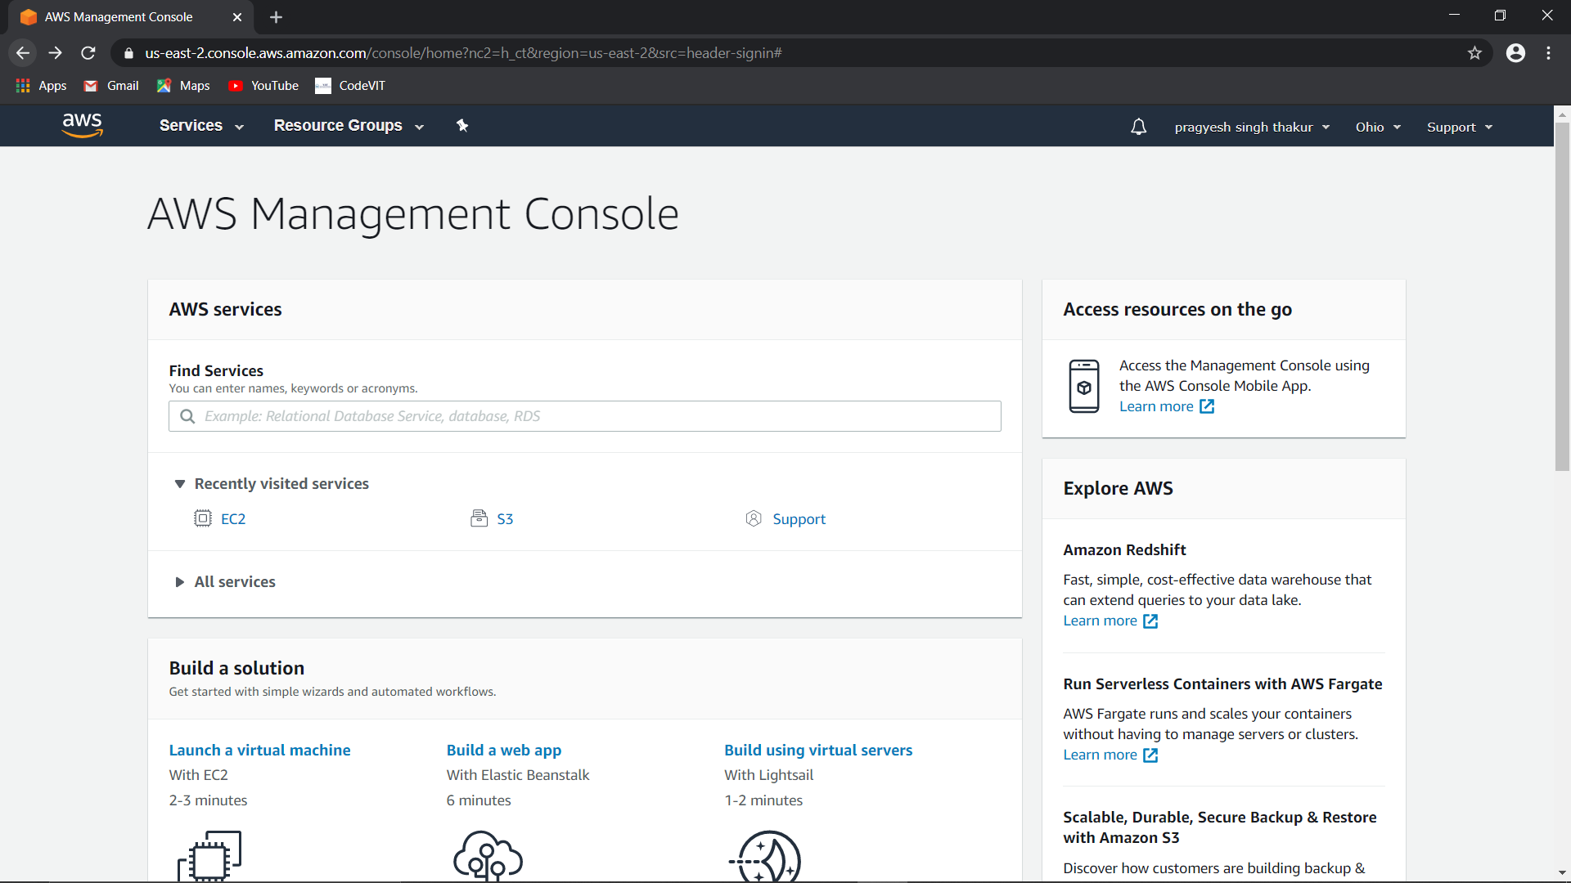

**EC2 DASH BOARD** 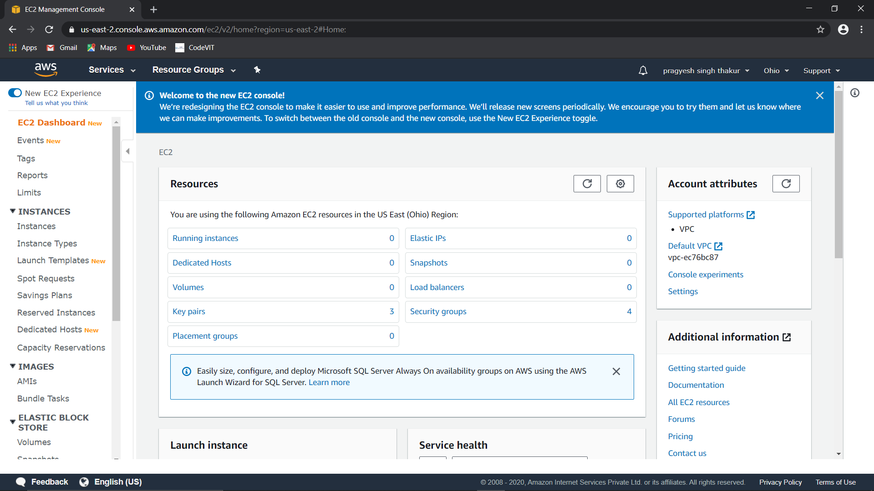

**CHOOSE AMI**

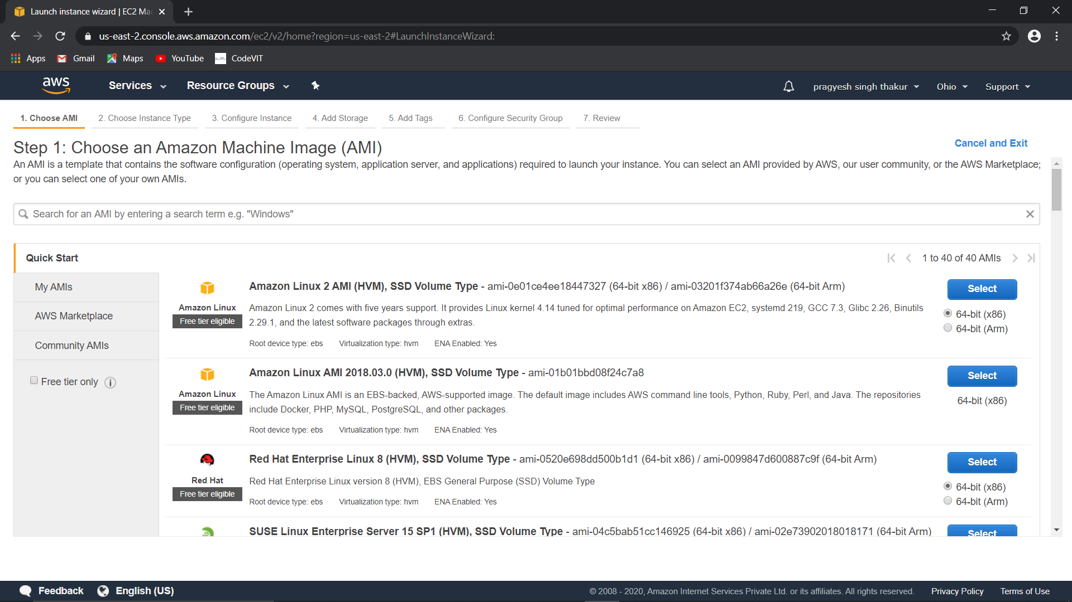

**CHOOSE INSTANCE TYPE**

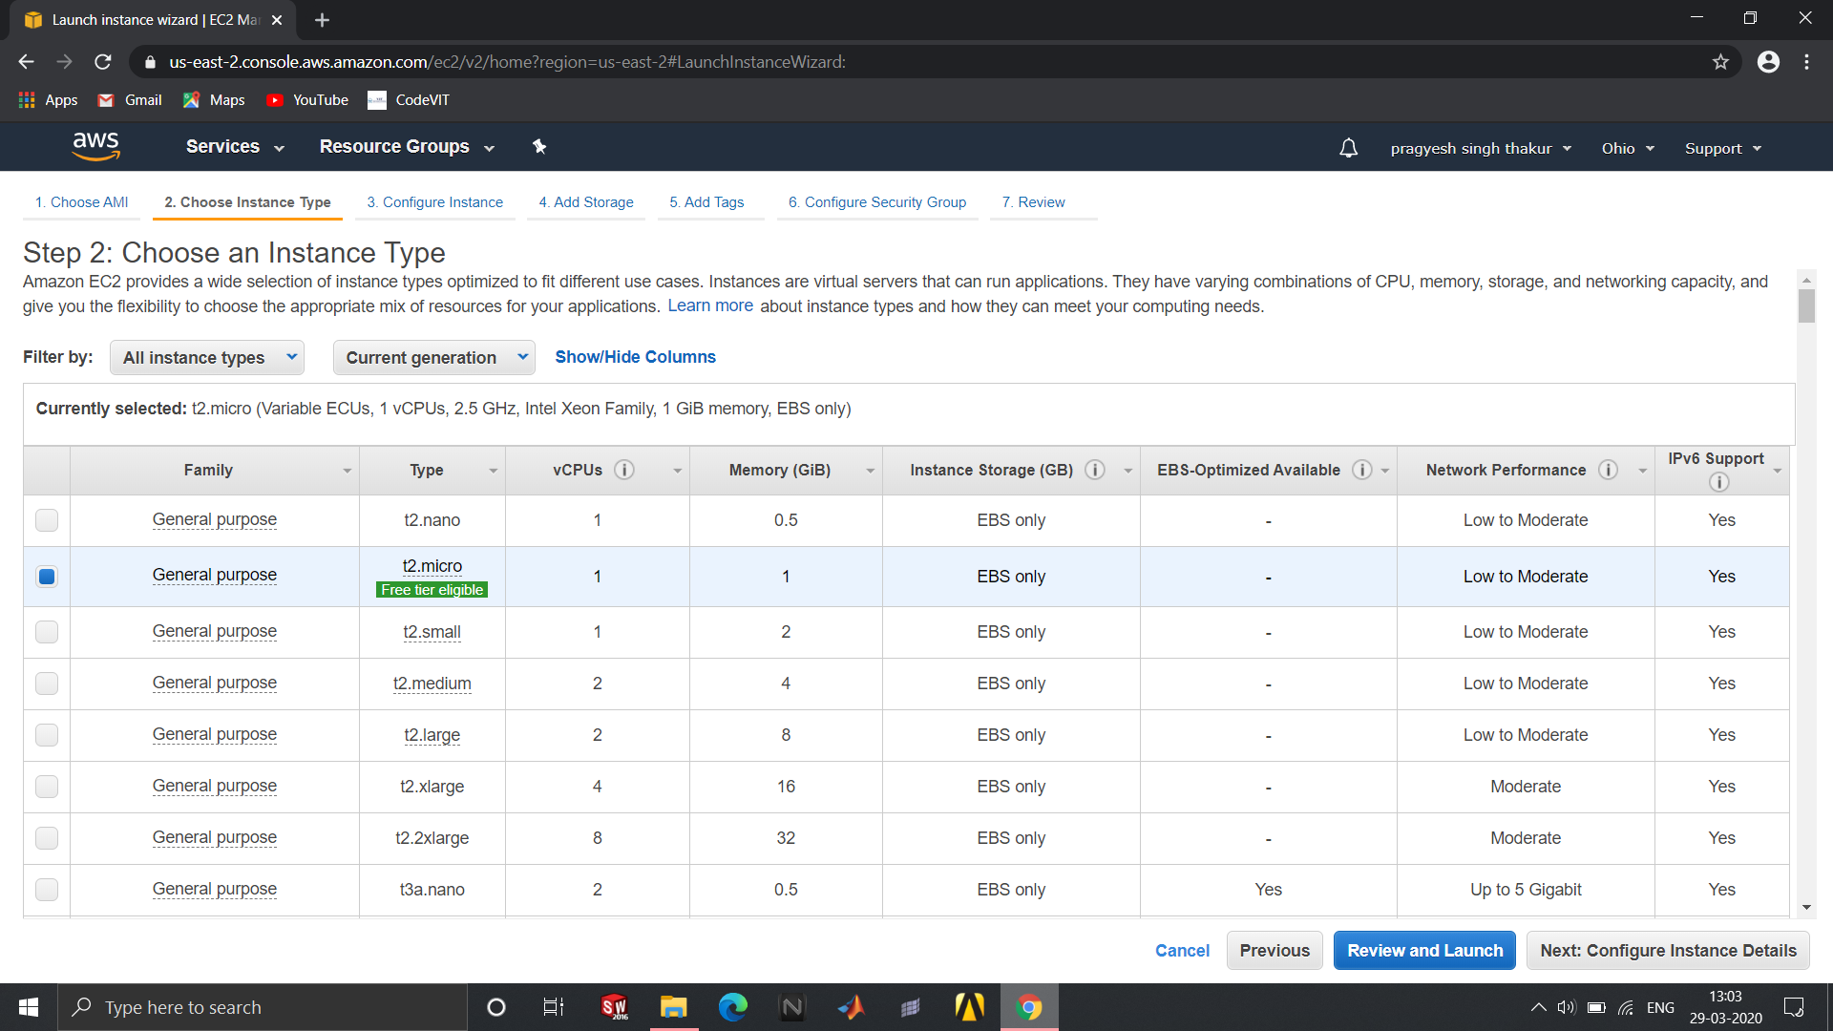

**CONFIGURE INSTANCE DETAILS**

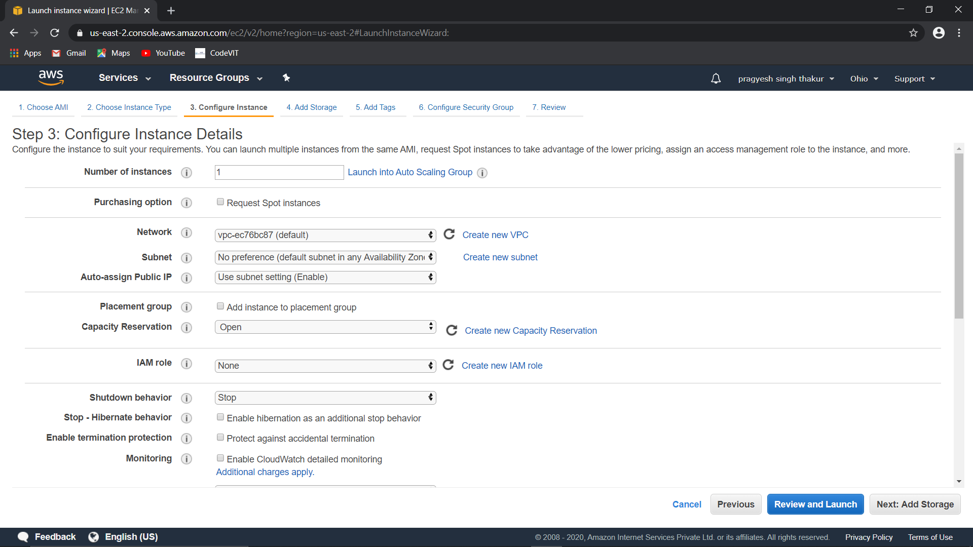

**ADD STORAGE**

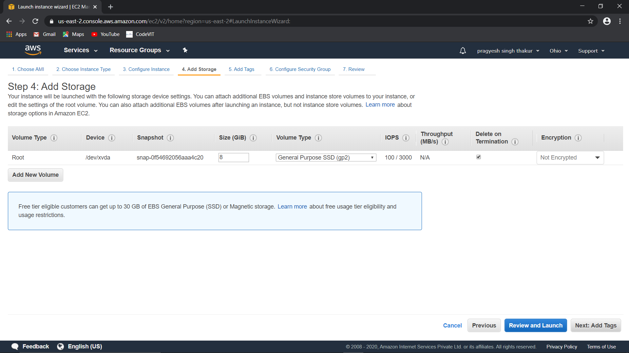

**CONFIGURE SECURITY GROUP**

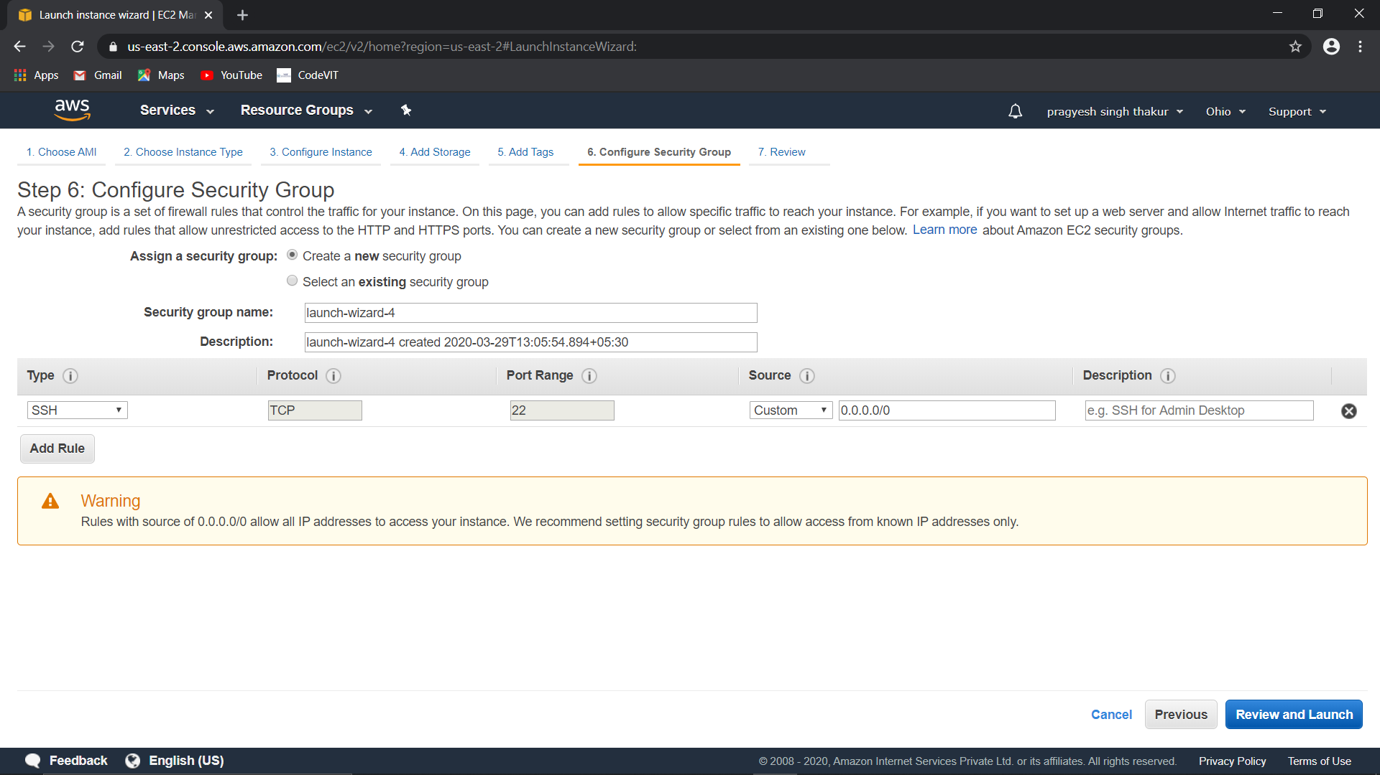

**INSTANCE LAUNCHED**

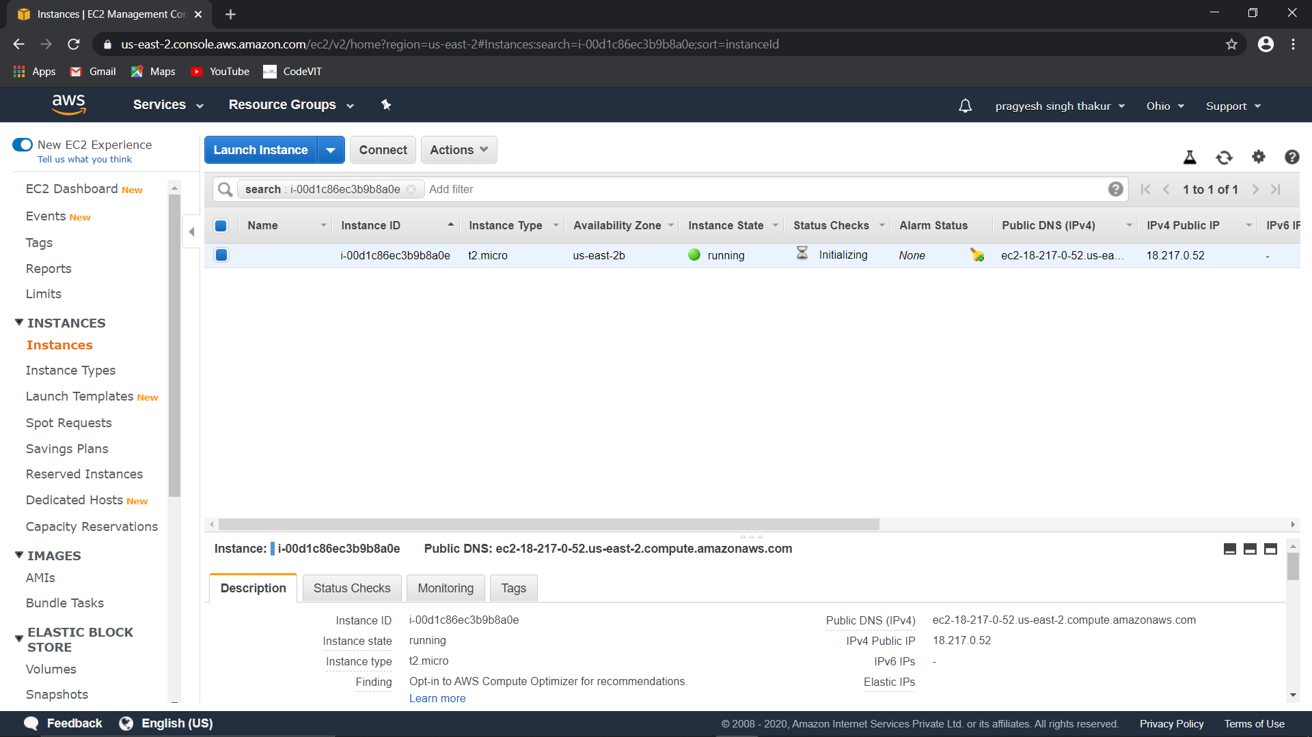

**DOWNLOADED KEY FILE**

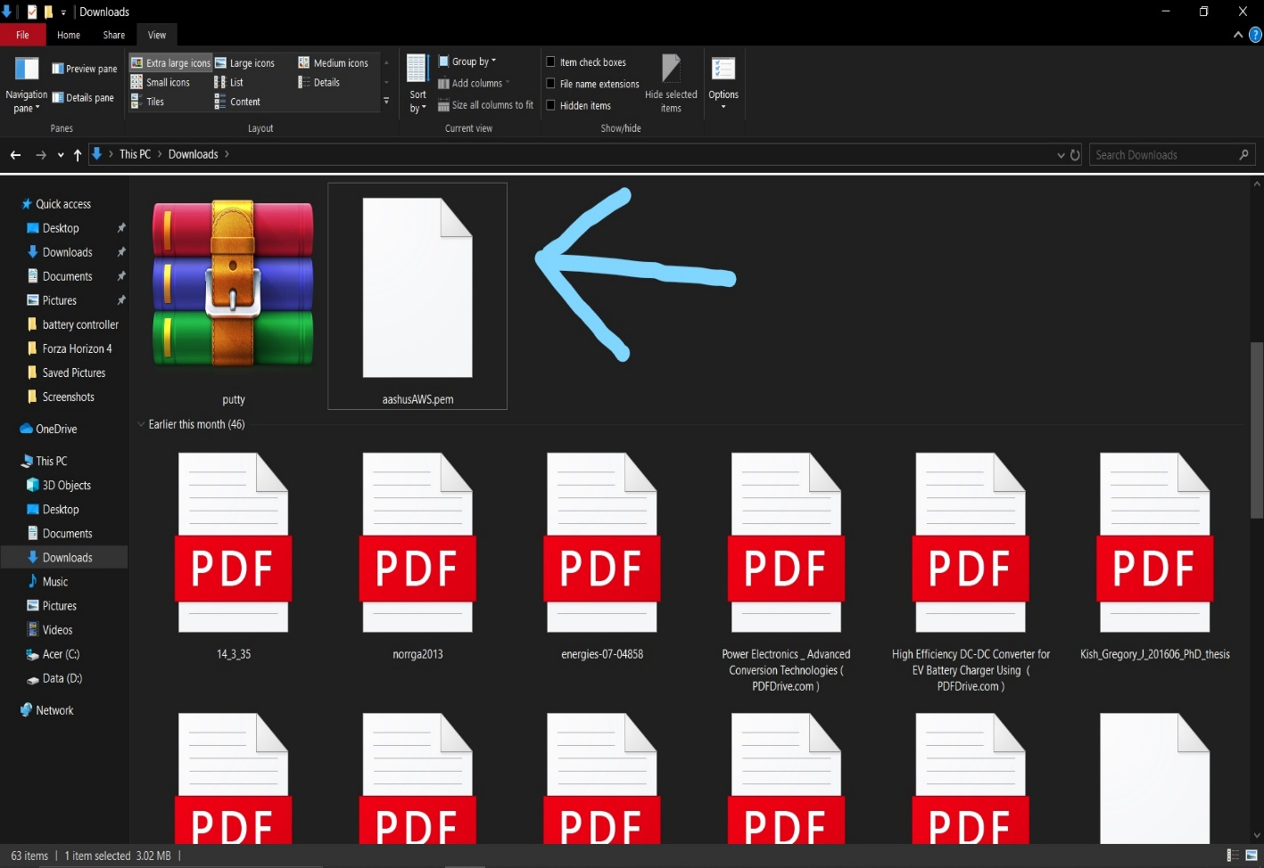

**PUTTYGEN FILE CONVERSION**

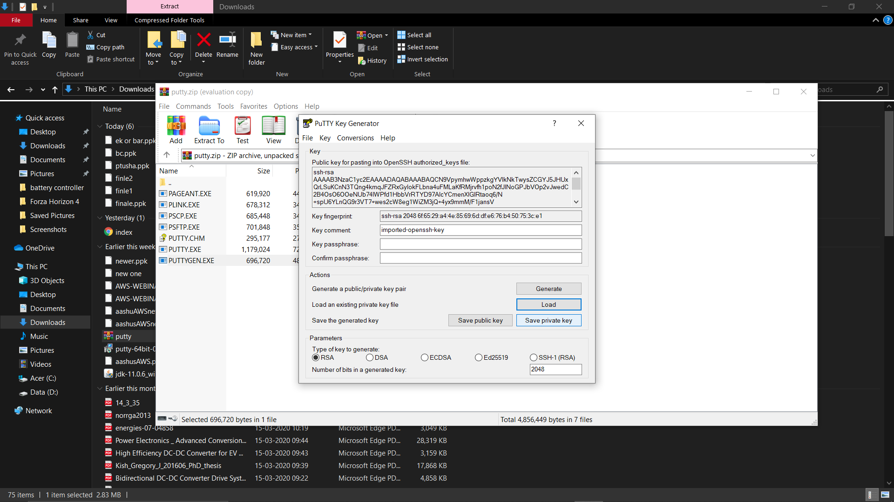

**PUTTY CONNECTING TO EC2**

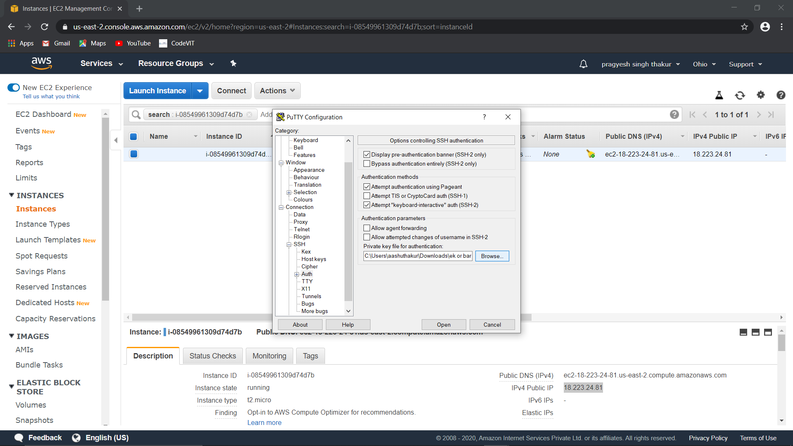

**EC2 SUCCESSFUL CONECTION**

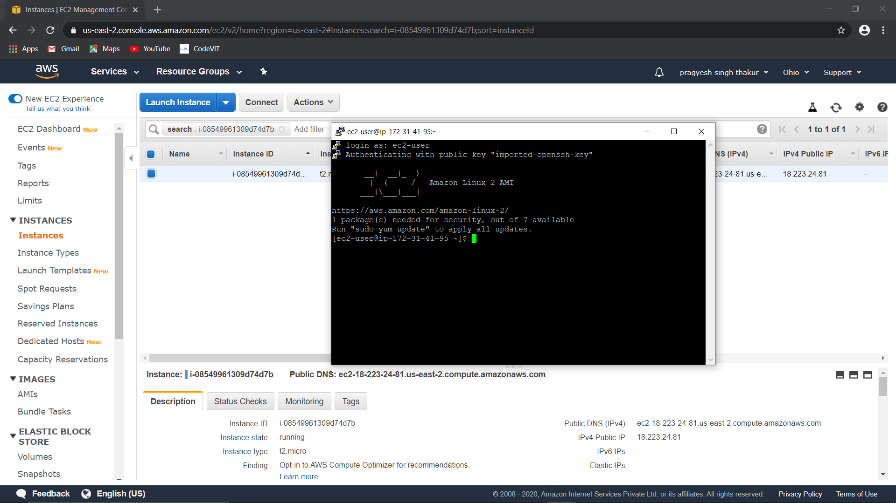

**IP ADRESS PUTTING THE NAME**

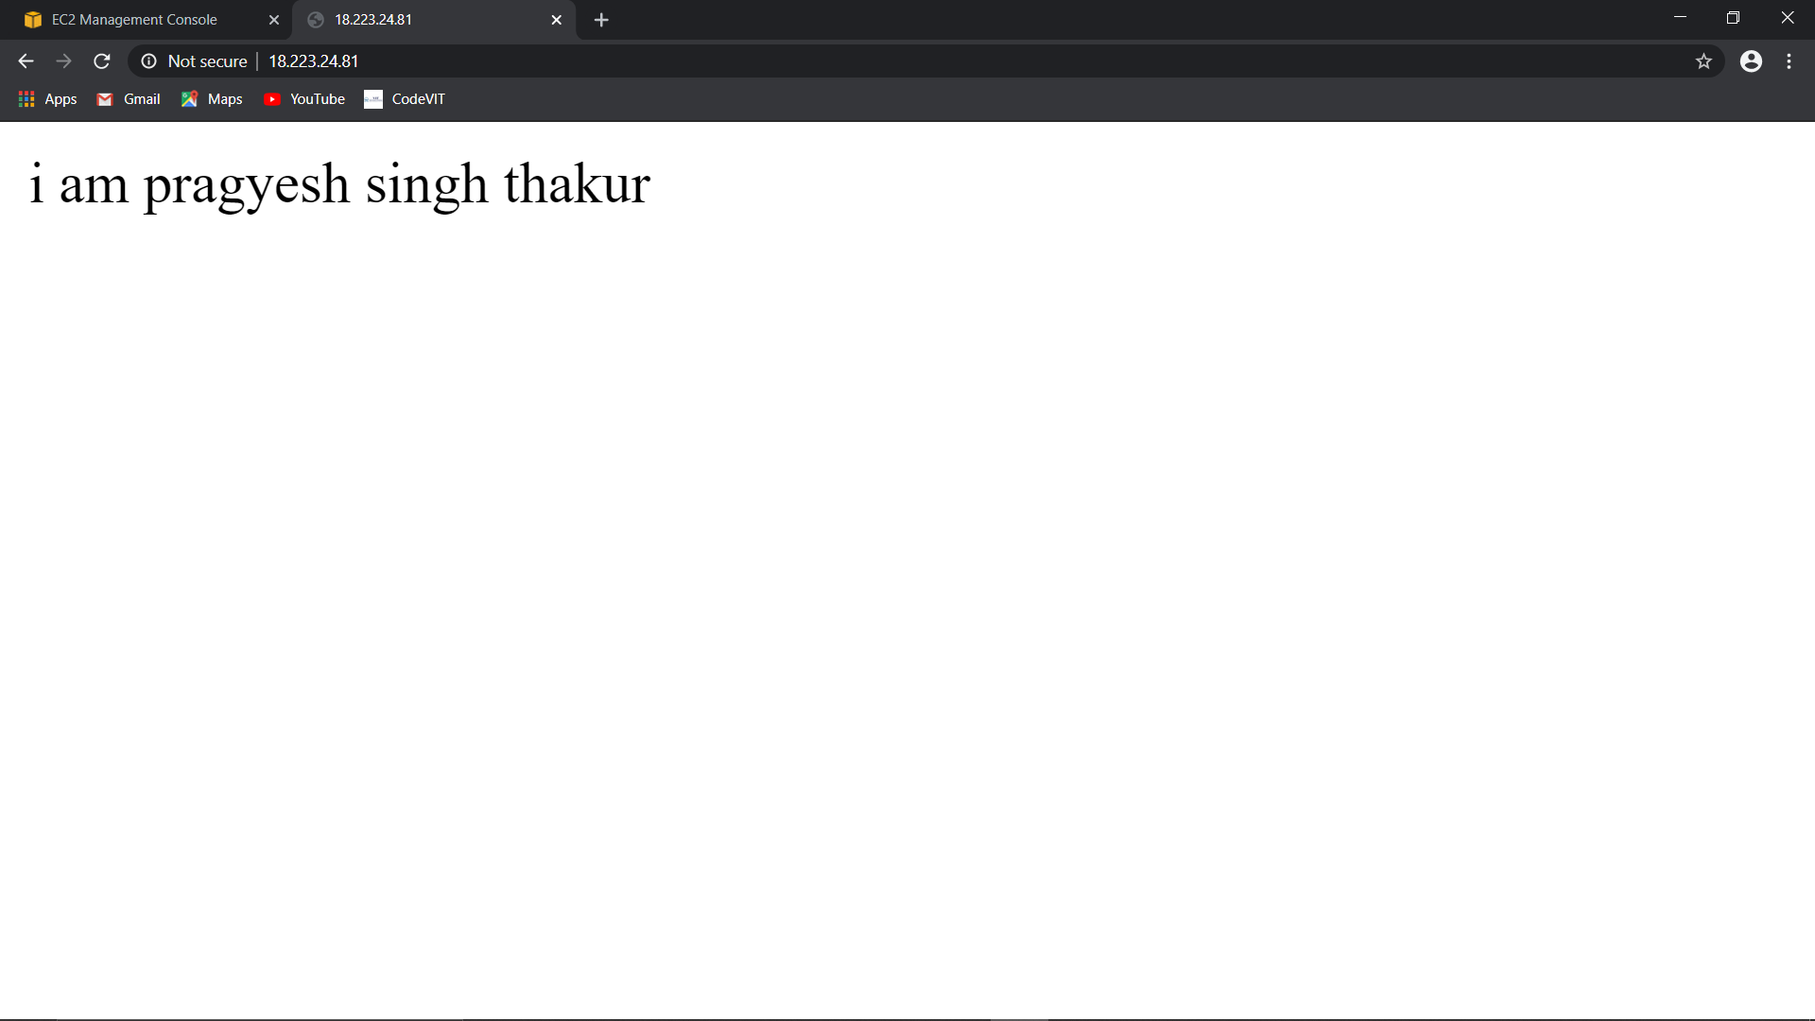

**CREATING BUCKET**

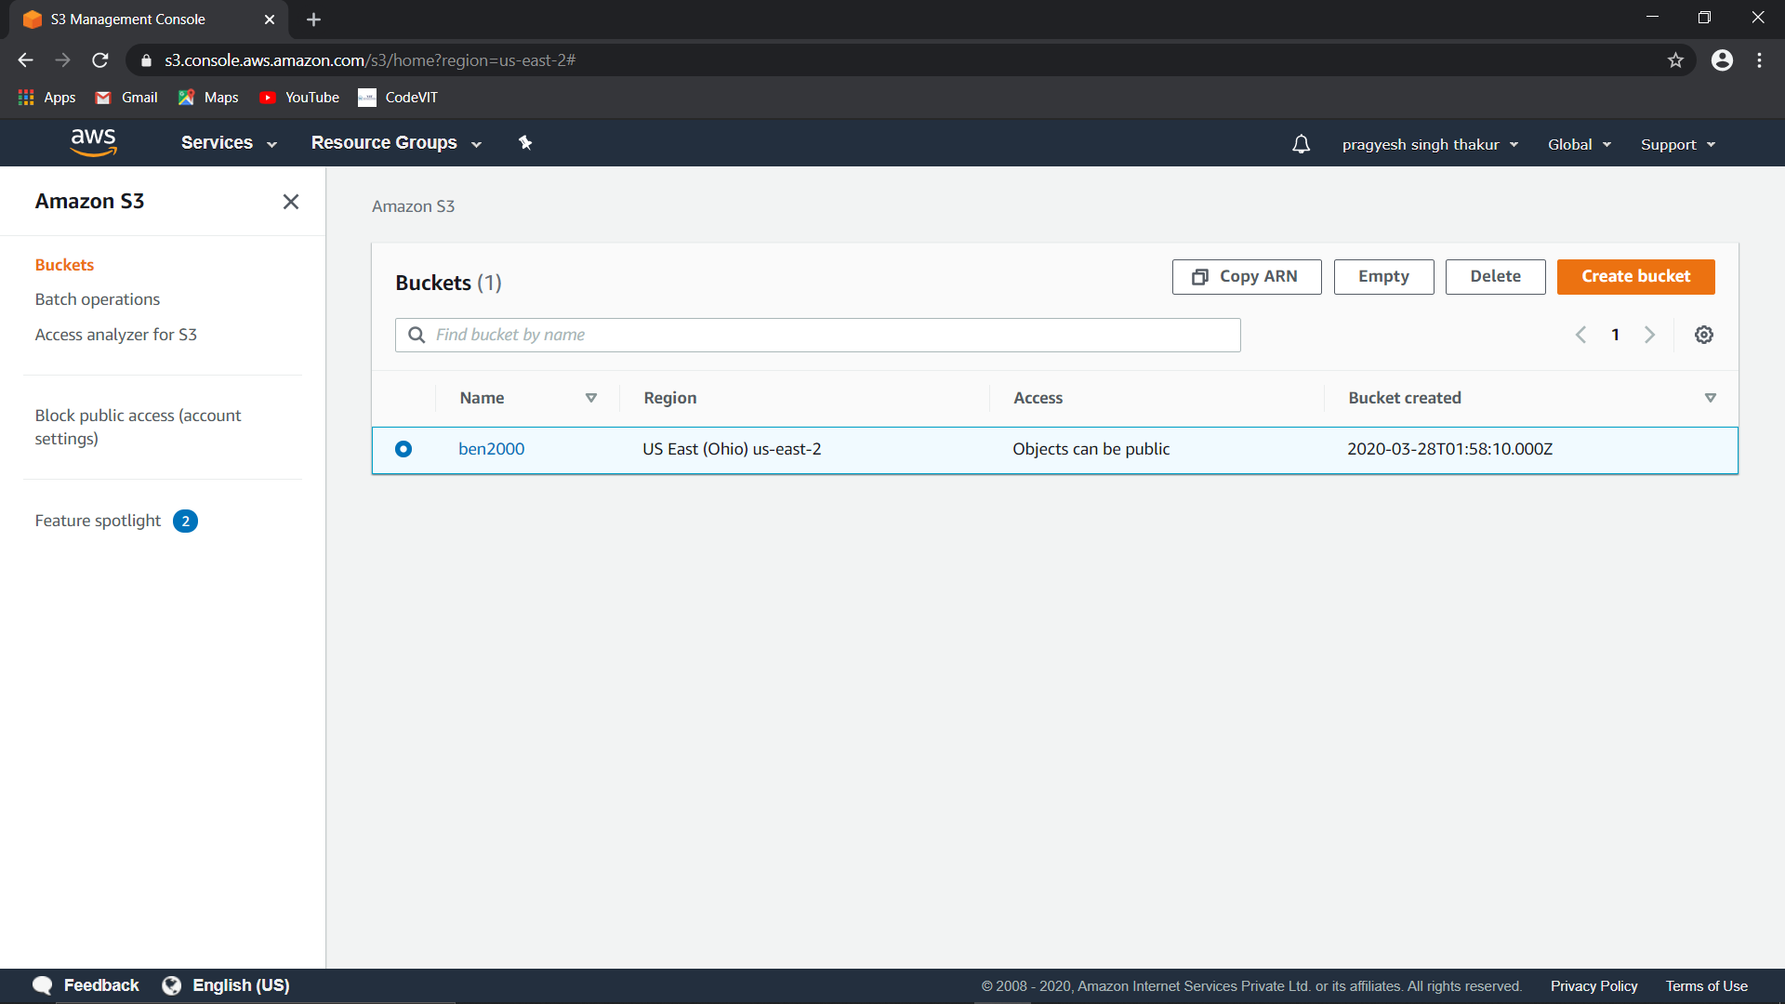

**ENABLINE STATIC WEBSITE HOSTING**

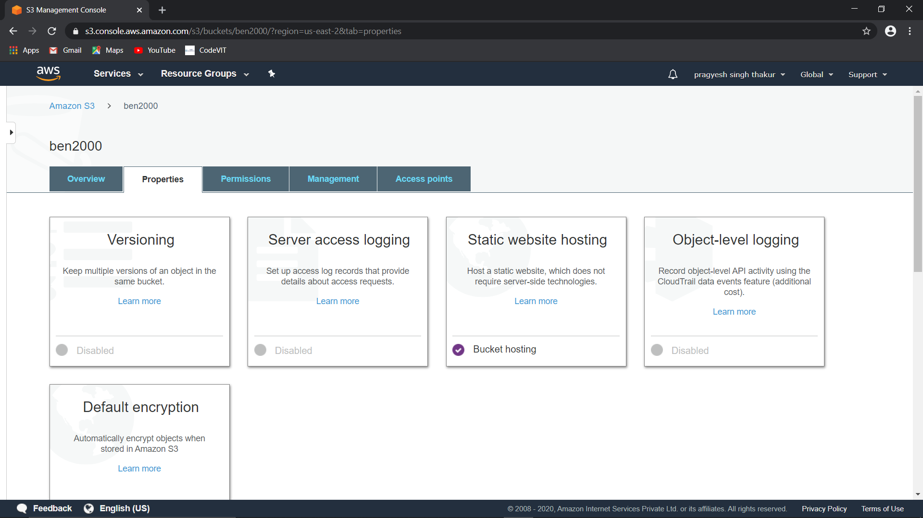

**OBJECT UPLOADING**

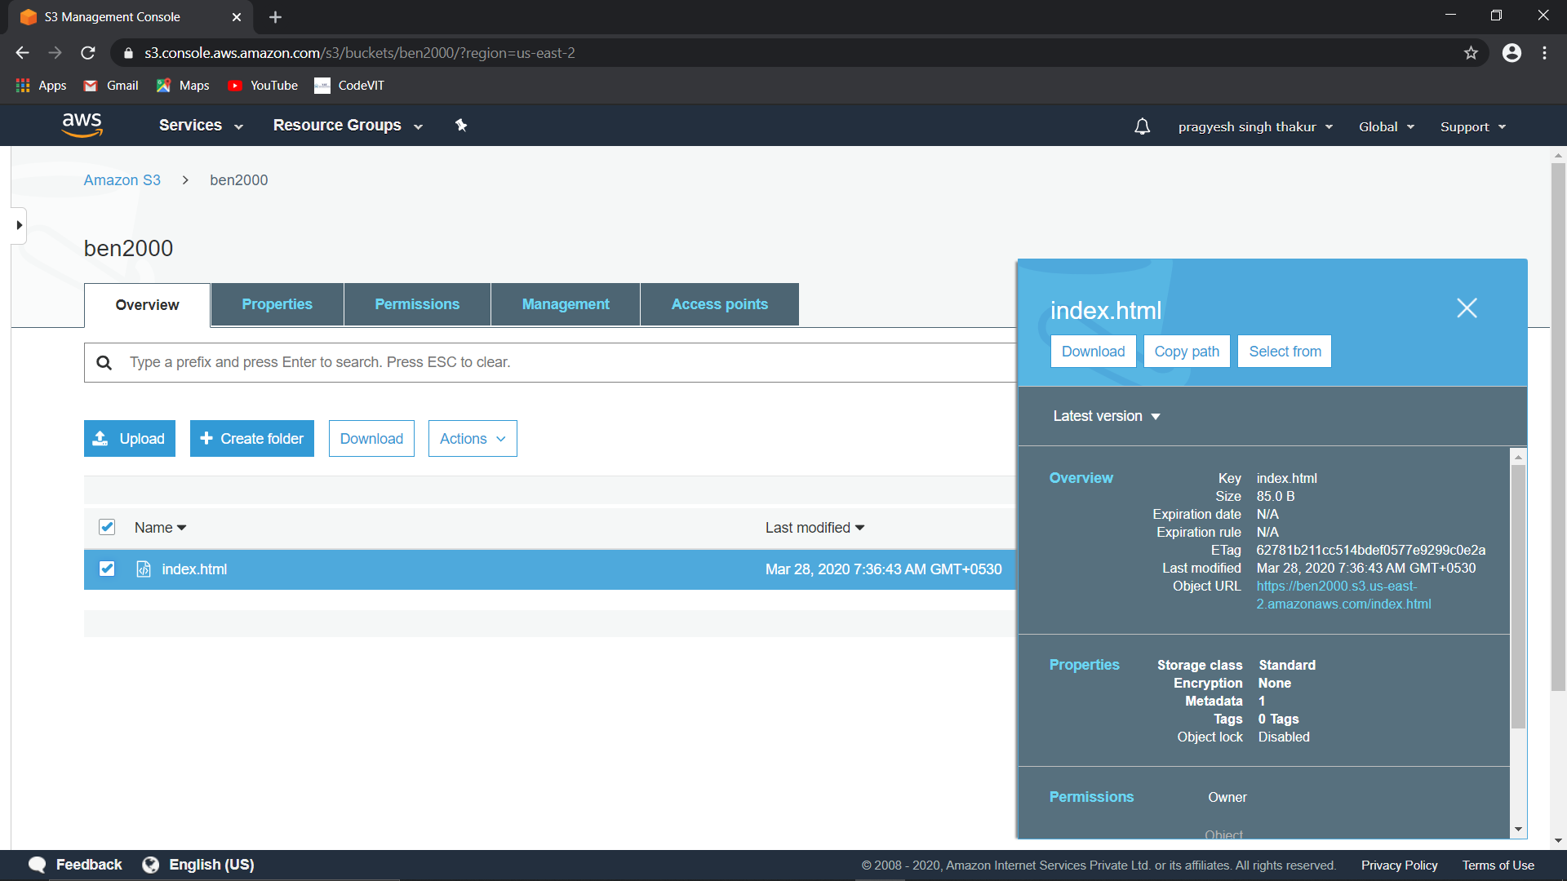

**MAKING OBJECT PUBLIC**

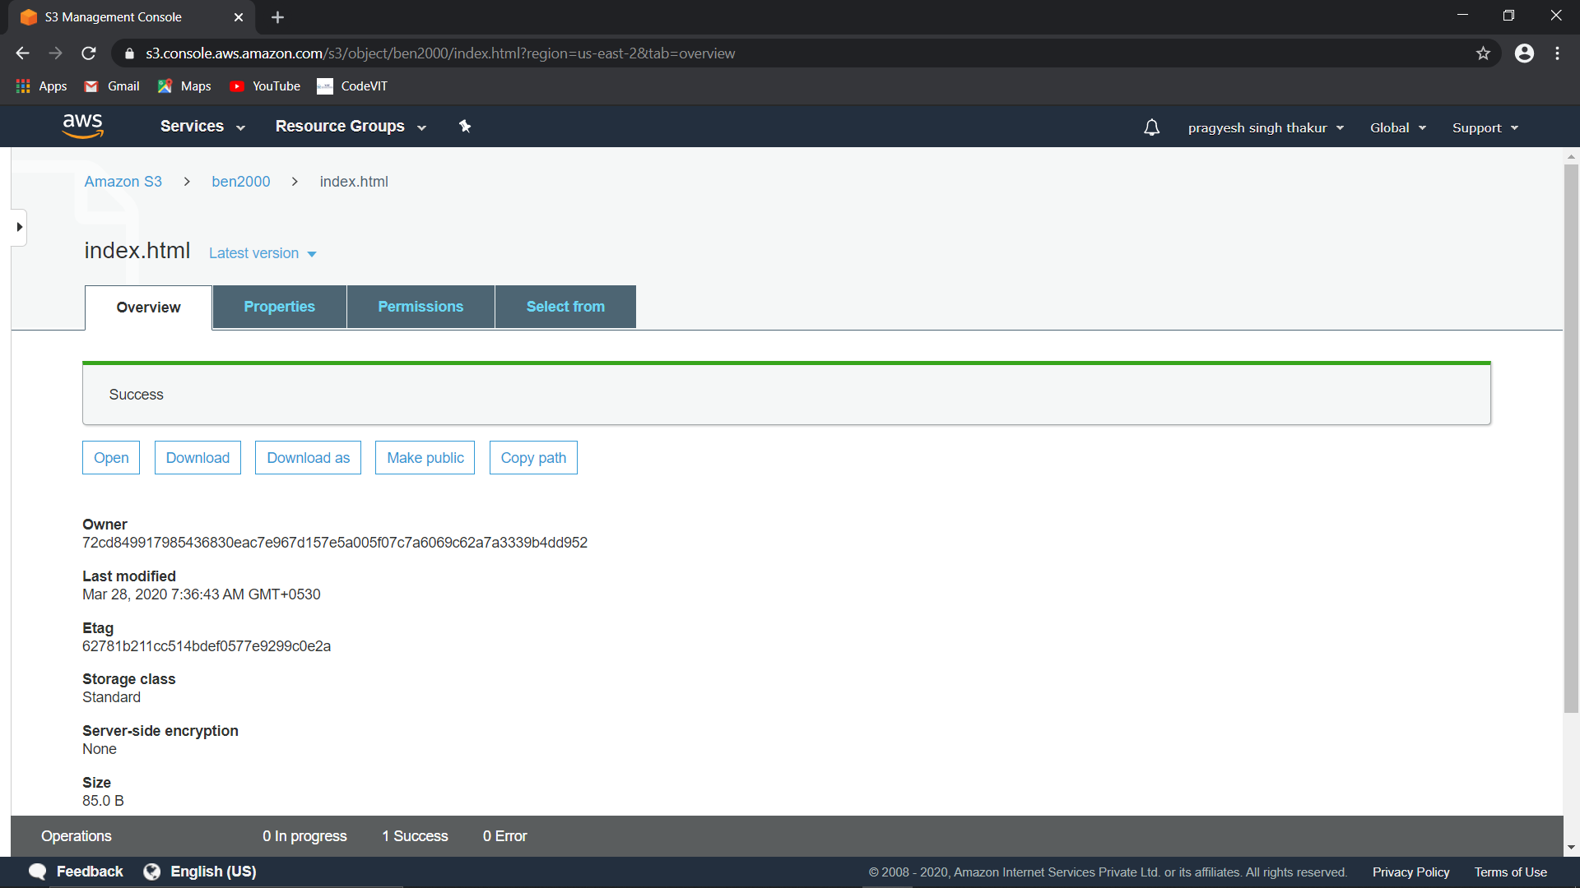

**BRAWSER LINK TESTING SUCCESS**

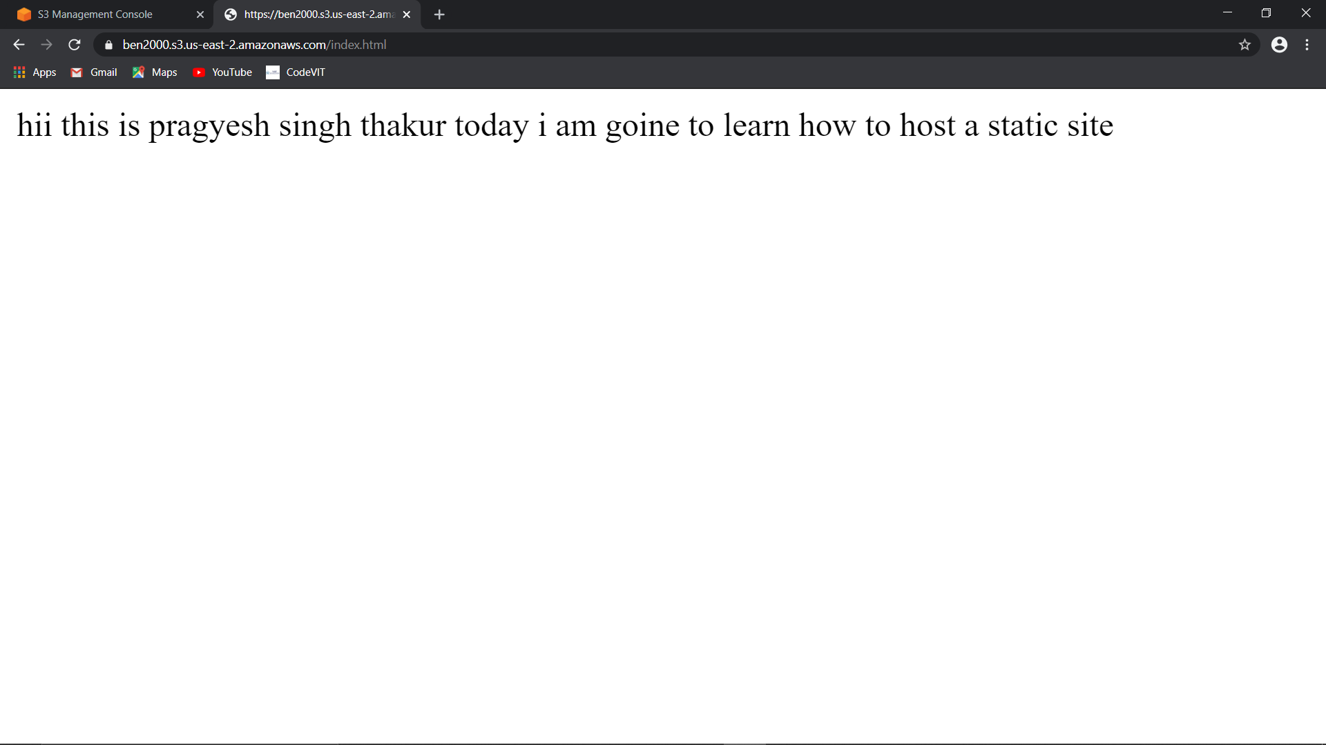

**INSTALLING PHP AND SDK**

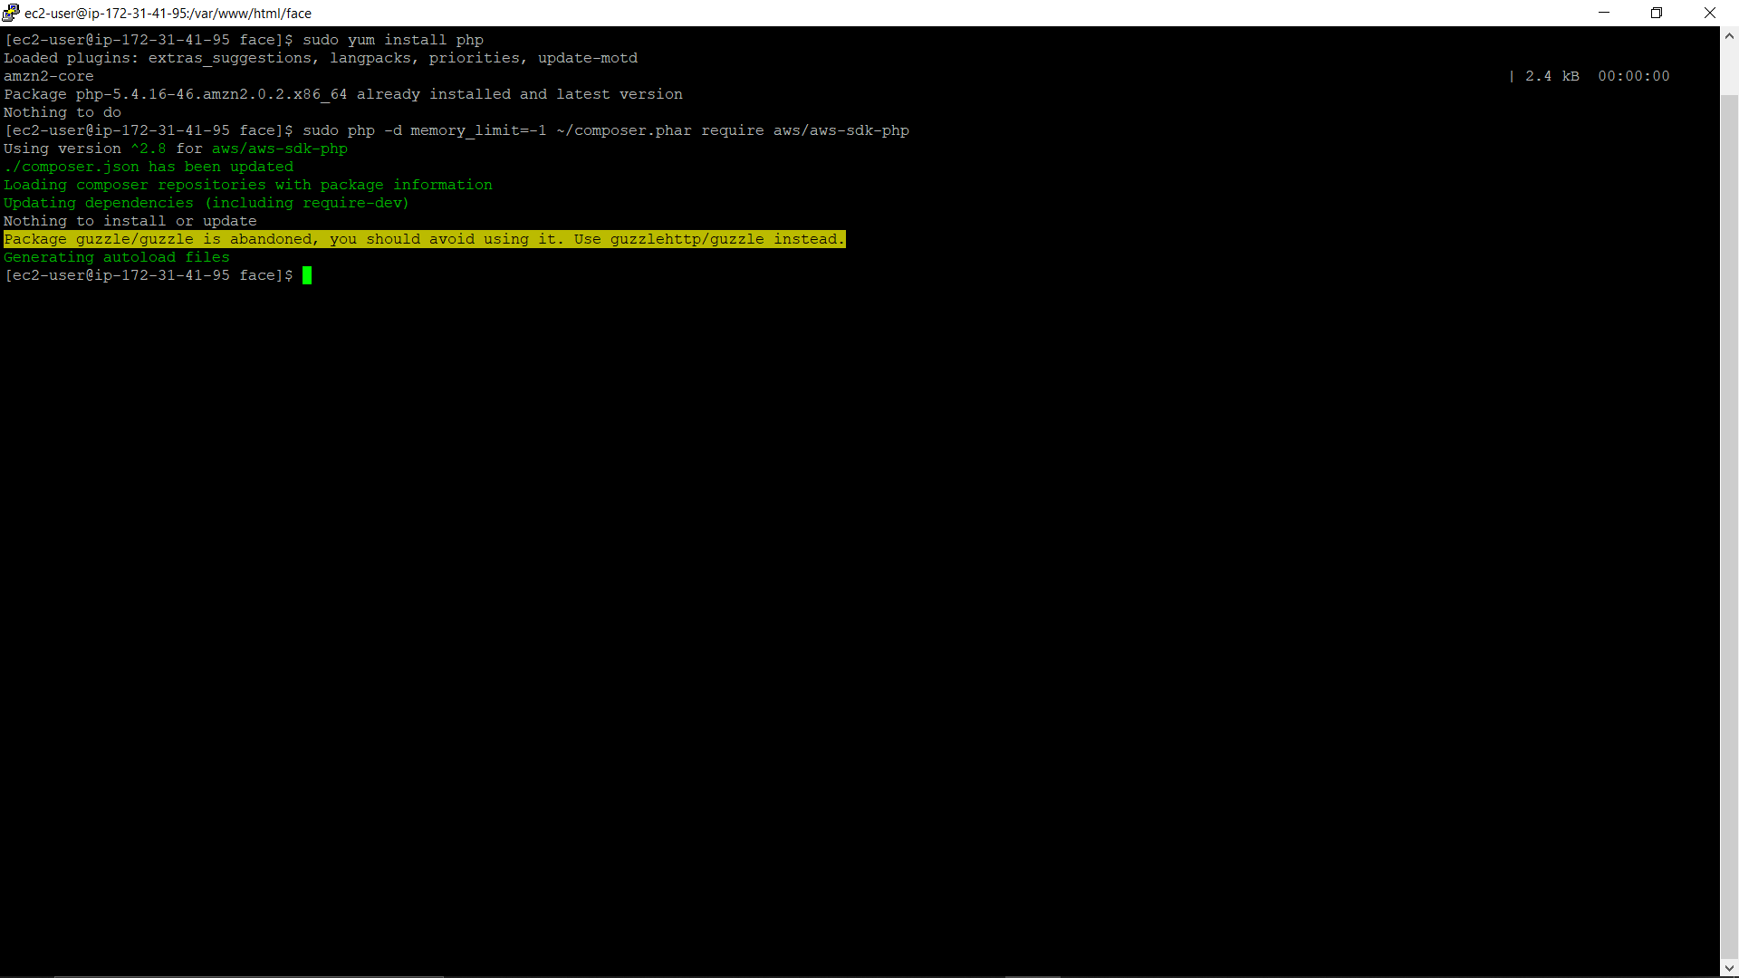

**UPLOADING DONE** 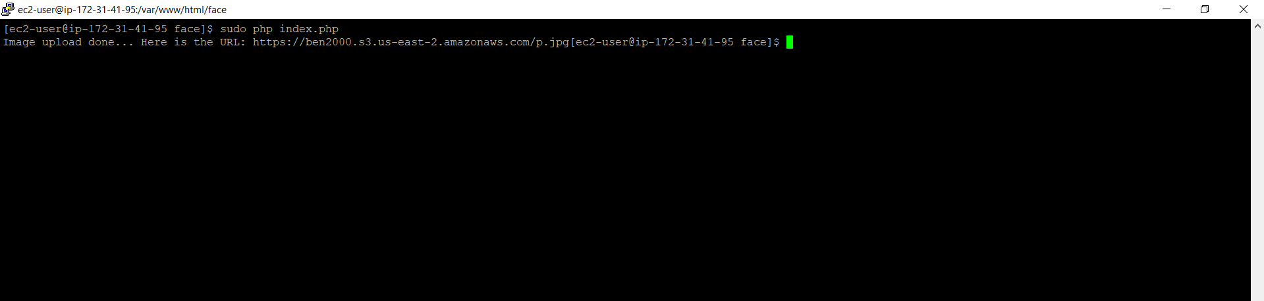

**UPLOADED PIC CHECKING IN THE BUCKET** 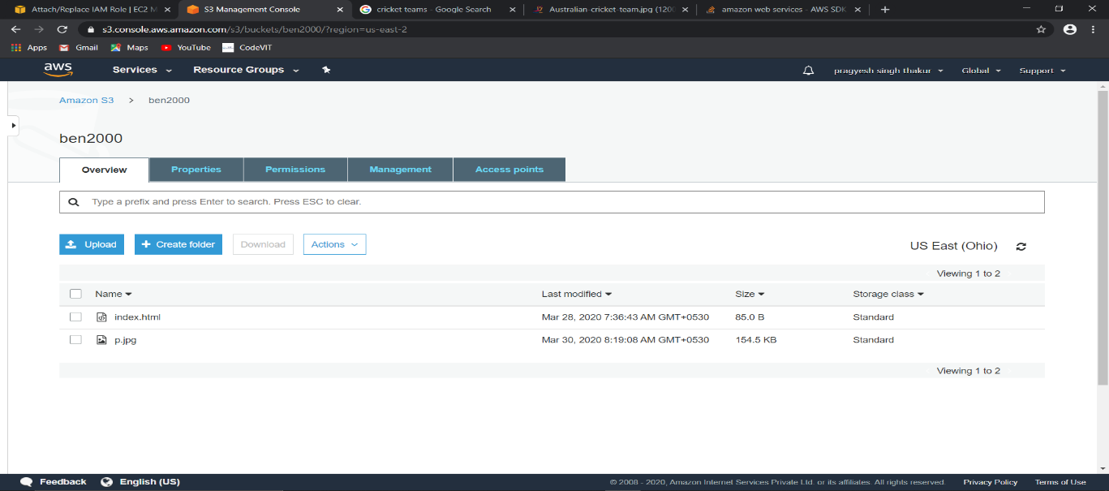

**FACIAL ANALYSIS**

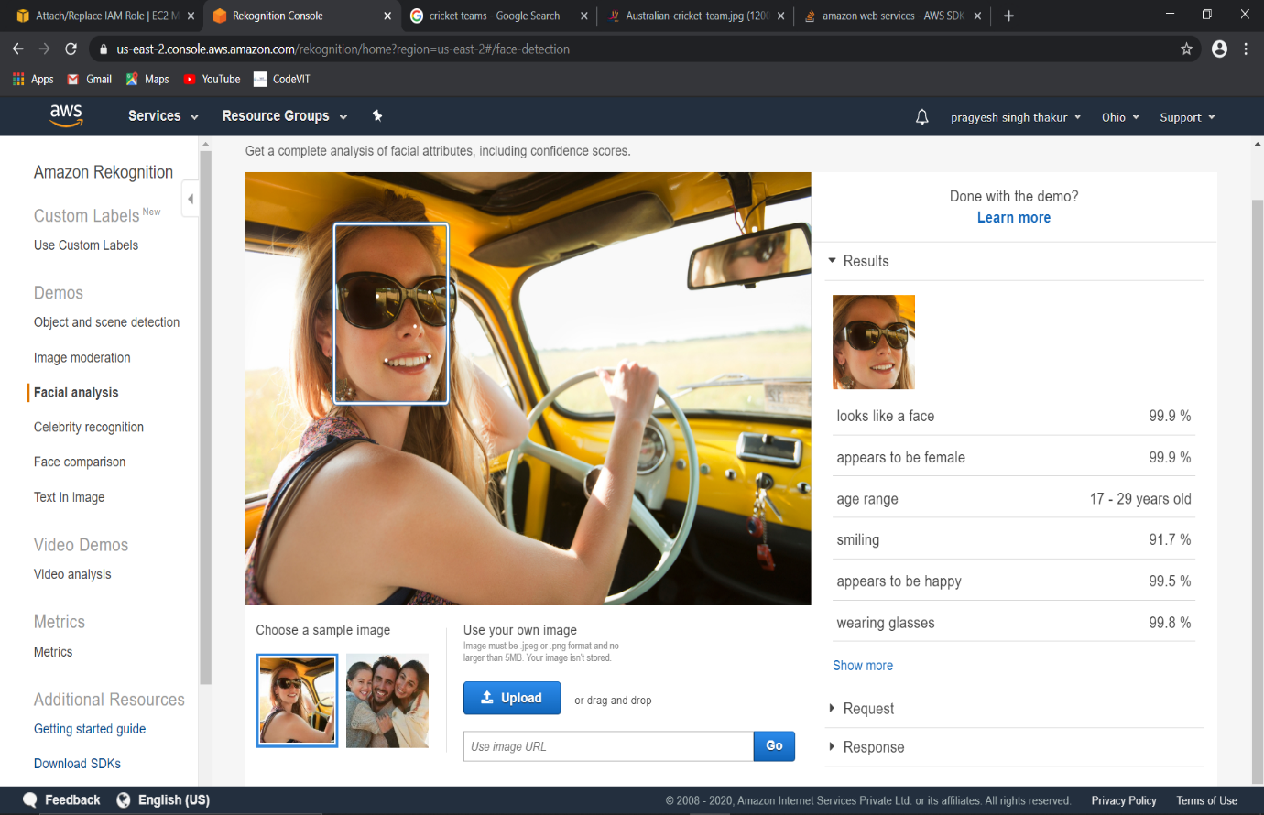

CELEBRITY RECOGNITION

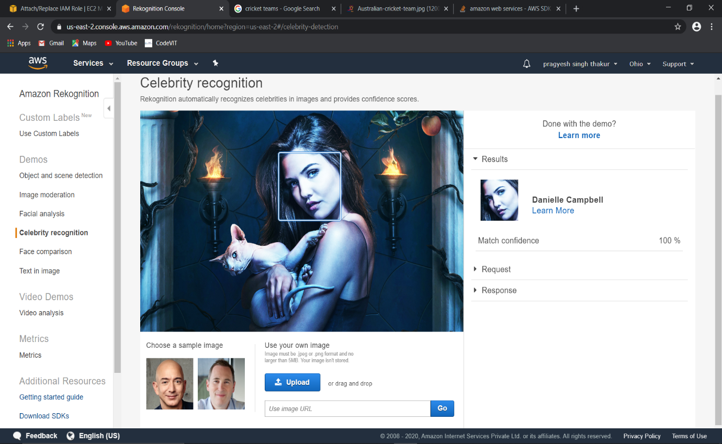

**FACE COMPARISON**

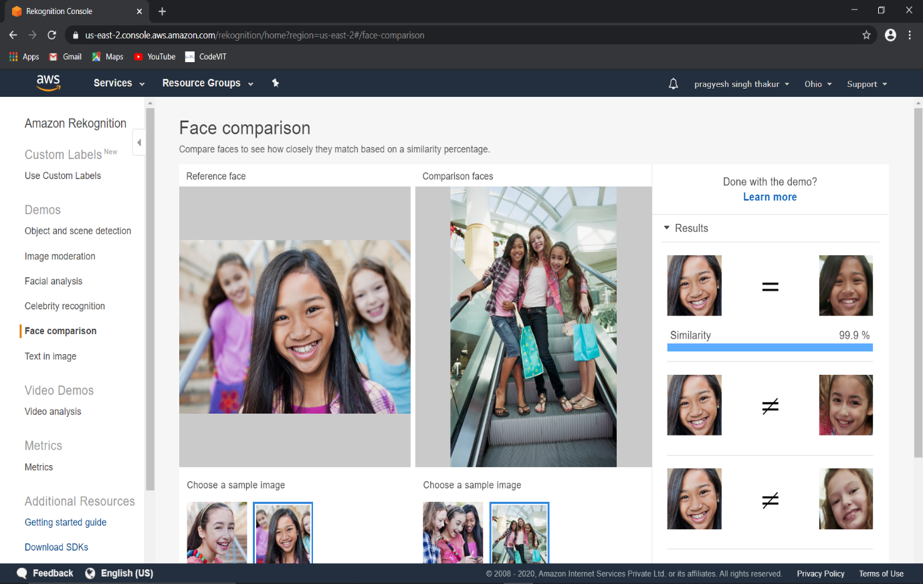

**TEXT IN TH IMAGE**

